24/7 Service Without the Overhead: The Rise of AI-Powered Member Concierge Agents

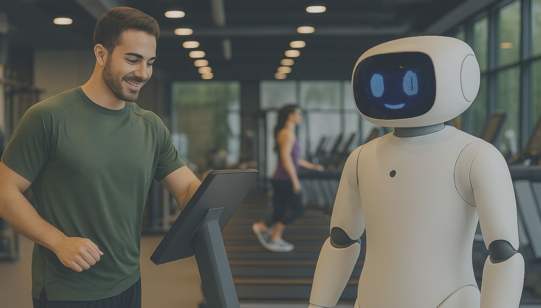

The fitness industry is built on experience. From the moment a prospective member walks through the door, every interaction shapes their perception of your brand. But delivering an exceptional experience 24/7 is a tall order. Staff shortages, inconsistent service, and rising operational costs make it nearly impossible for gyms and studios to maintain a high level of service around the clock.

Enter AI-powered Member Concierge Agents – your secret weapon for delivering seamless, personalized support without overhead.

What Is a Member Concierge Agent?

A Member Concierge Agent is an AI-powered assistant designed to handle member interactions across all touchpoints, from your website and mobile app to in-club kiosks and chat platforms. Think of it as a 24/7 front-desk associate that never takes a break, consistently providing top-notch service.

These AI Agents specialize in managing:

* **Member Inquiries:** Instantly respond to FAQs about memberships, class schedules, amenities, and pricing.
* **Class Bookings:** Enable easy, real-time class reservations with personalized recommendations.
* **Account Management:** Assist with billing questions, membership upgrades, and contract adjustments.
* **Troubleshooting:** Offer step-by-step solutions for common technical issues.

And they do it all without human intervention, reducing the burden on your staff while maintaining high member satisfaction.

**Why Fitness Operators Are Turning to AI Concierge Agents**

**1. 24/7 Availability Without the Staffing Challenges**

Your members expect instant responses, whether it’s 6 AM or midnight. Staffing to meet this demand is costly and impractical. An AI Member Concierge Agent ensures no query goes unanswered, providing immediate support anytime, anywhere.

**Fact:** 40% of gym members prefer self-service options for managing their memberships. An AI Agent ensures these preferences are met without adding headcount.

**2. Personalized, Human-Like Interactions**

AI Concierge Agents use Natural Language Processing (NLP) to understand intent, respond conversationally, and offer personalized recommendations. They analyze member data to suggest the best classes, provide fitness tips, and recommend relevant services.

**Example:** “Hi Sarah! Based on your past classes, you might enjoy our new HIIT session this Thursday at 7 PM. Would you like me to book it for you?”

**3. Operational Efficiency at Scale**

With an AI Agent managing repetitive tasks, your staff can focus on delivering personalized, high-value experiences. Whether it’s conducting facility tours, supporting personal training sessions, or driving sales, your team’s time is spent where it matters most.

**Stat:** Fitness operators report a 30-50% reduction in administrative workload after implementing AI Concierge Agents.

**4. Revenue Growth Through Smart Upselling**

AI Concierge Agents aren’t just for support – they’re revenue drivers. By analyzing member behavior, they can recommend relevant upsells like personal training packages, nutrition plans, or specialty classes, all within a seamless conversation.

**Real-World Impact:** One fitness chain using AI Agents saw a 20% increase in upsell conversions within the first 90 days.

**5. Member Retention Through Proactive Engagement**

AI Concierge Agents can detect early signs of disengagement by monitoring changes in activity levels, canceled bookings, or negative feedback. They then trigger personalized outreach to re-engage members before they churn.

**Insight:** A proactive retention strategy powered by AI can reduce member churn by as much as 15%.

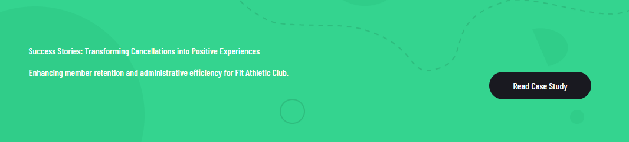

Success Stories: Fitness SF

Enhancing Gym Member Engagement and Conversion with AI Agents for Fitness SF [Read Case Study](https://dxfactor.com/case-studies/fitness-sf-fitgenai/)

**AI in Action: A Day in the Life of a Member Concierge Agent**

Imagine how an AI Concierge Agent might enhance your club’s operations over the course of a day:

* **6:00 AM:** A member checks the app to see which classes are available. The Agent suggests a yoga class and completes the booking in seconds.
* **10:30 AM:** A prospective member visits your website. The Agent engages, answers questions about pricing, and schedules a facility tour.
* **2:00 PM:** A member’s credit card fails during a recurring payment. The Agent sends a polite notification with a direct link to update the card.
* **7:00 PM:** After a workout, a member leaves feedback. The Agent acknowledges it, addresses concerns, and escalates the issue if necessary.
* **9:00 PM:** A parent inquires about family memberships. The Agent highlights available options and processes the upgrade instantly.

**Is an AI Concierge Agent Right for Your Gym?**

If you’re dealing with any of these challenges, it’s time to consider implementing an AI Member Concierge Agent:

* High call volume overwhelming your staff
* Members frustrated by delayed responses
* Limited staffing during non-peak hours
* Missed revenue opportunities from upsells
* High member churn due to lack of proactive engagement

**Get Started with AI-Powered Member Support**

The rise of AI-powered Member Concierge Agents is redefining fitness customer service. Operators who leverage this technology are not only enhancing member satisfaction but also driving operational efficiency and revenue growth.

Ready to see how a Member Concierge Agent can transform your fitness business?

[Let’s talk.](https://calendly.com/meetwithron-dx/30min) Reach out to learn how DXFactor can deploy an AI Concierge Agent that’s customized to your brand and designed to deliver measurable results.

The future of fitness is here, and it’s AI-powered.

**Blog Tags**

Fitness

Agentic AI

Operational Efficiency

**Proposed URL & UTM URL**

<https://dxfactor.com/why-your-gym-needs-agentic-ai-now>

<https://dxfactor.com/why-your-gym-needs-agentic-ai-now?utm_source=rblinkedin&utm_medium=social&utm_campaign=marketing-usa&utm_content=sales-insights&utm_term=agentic-ai>

**Meta Title (Under 60 Characters):**

Why Your Gym Needs Agentic AI Now

**Meta Description (Under 155 Characters):**

Discover how Agentic AI is reshaping fitness by boosting efficiency, saving staff hours, and enhancing the member experience across gym operations.